STAT112 Introduction to Data Processing and Visualization Project
Analysis On Sales of Different Featured Laptops
Yağmur Çınar 2561157
Selin Deniz 2561199
Rümeysa Daştan 2561173
Ahmet Doğan 2426401

Middle East Technical University
ABSTRACT
This investigation is about different brands of laptops which are on sale. The given dataset includes different variables and information about hardware components which are related to laptops. Data tidying and cleaning was necessary for given dataset in regards of to get meaningful inference in process of analyzing and visualization. Associations analyzed between many numerical and categorical data sets as a result of research questions on the clean data.

INTRODUCTION
This analysis mainly examined the prices and the brands of the laptops throughout the years with respect to the other hardware components information. The dataset includes 150 rows and 11 columns. Analyses mainly done within the scope of variables, which are brand, price, weight, display size, year, and processor. Original dataset contained 11 variables:

Variable Name | Description | Scale
ID | Unique identifier for each laptop. | Nominal, Discrete
Brand | Representing the brand. | Nominal
Processor | Indicating the type of processor. | Nominal
RAM | RAM size in gigabytes. | Ordinal, Discrete
Storage | Indicating the storage capacity. | Nominal, Discrete
Graphics | Type of graphics card. | Nominal
Display Size | The size of the laptop display in inches. | Ratio, Continuous
Condition | Indicating the condition. | Nominal
Year | The year of the laptop model. | Interval, Discrete
Price | The price of the laptop in dollars. | Ratio, Continuous
Weight | The weight of the laptop in kilograms. | Ratio, Continuous

- Research Questions:
- How does the average price of laptops change over the years from 2020 to 2023?
- In which way does condition affect average prices based on brands?
- How does display size vary among brands?
- Which weight of laptops are preferred more by users?
- How processors affect laptop’s costs?

DATA TIDYING AND CLEANING STEPS

In data science, data visualization and data analytics; data cleaning is the act of organizing and correcting incorrect, messy, and unreliable structured data in order to get accurate findings. NumPy and Pandas were used for given dataset while implementing steps below:

- Pandas, Numpy, Seaborn and Matplotlib libraries were imported into the notebook file.
- The Excel File was read as a DataFrame by using the pd.read_excel method from the Pandas Library.
- To examine the inaccuracies in titles, seperations, letter casses, data types and to detect NaN values briefly; .head(), .tail() and .info() functions were used.
- By using header function and with .iloc[] method, the first two rows and first tree columns were dropped since they were empty and unnecessary lines.
- By str.title() function, titles were examined. Then str.strip() and .rename() functions were used to remove unnecessary marks and change misspelled title names to better forms.
- Number of duplicated values were detected with .duplicated().sum() function and deleted by using .drop_duplicates() function.
- Different units were converted to correct form with .loc[] function, unnecesarry marks and units were deleted by using .str.replace( , regex=True) function.
- ‘Storage(GB)’, ‘Ram(GB)’, ‘Display Size’, ‘Weight’ and ‘Price’ were in wrong data types. First, ‘Storage(GB)’, ‘Ram(GB)’, ‘Display Size’, ‘Weight’ were converted to float type by using .astype(float) function. Afterwards, ‘Storage(GB)’, ‘Ram(GB)’, ‘Price’ were converted to integers with .fillna(0).astype(int) function.
- To check whether all strings are in the same format for each column, .value_counts() function was used.
- There were some irrelevant strings detected in ‘Brand’ and ‘Condition’ columns such as “APPLE”, “ refurbished”, “USED”; they changed into same formats with .loc[] function.
- Missing and null values and their percentages in the dataset were checked by using .isnull().sum() function and since there was not a column which included missing value more than %65, none of the columns were removed.
- Null values were deteceted in ‘Storage(GB)’, ‘Graphics’, ‘Display Size’, ,’Condition’, ‘Price’ and ‘Weight’ columns.
- Outlier values were checked with proper functions in ‘Display Size’, ‘Price’, ‘Weight’ since these columns include float data. Only in ‘Price’ column, there were 2 outliers detected.
- Outlier values were filled with rounded mean value of ‘Price ‘ column.
- Null values were filled with mean values on ‘Weight’ and ‘Display Size’ columns since there were no outlier values in these columns.
- Null values were filled with median value on ‘Price’ column because there were outliers in this column.
- Null values were filled with median on ‘Storage(GB)’ column, and null values on ‘Graphics’ and ‘ Condition’ were filled with mode.
- ‘Price’ were converted into integer with .fillna(0).astype(int) function after filling NaN and outlier values into appropriate values.
- Commas were converted to dots with str.replace() function on ‘Weight’ column in regards to change ‘Weight’ column into proper form which is float with .astype(float) function.
- Dataset were checked if it is in proper form after cleaning and tyding steps with .isnull().sum() and .info() functions.
- Descriptive statistics of the cleaned dataset were examined with .describe() function.
- Finally, the excel file were changed with the cleaned dataset by .to_excel( , index=False) function.

EXPLORATORY DATA ANALYSIS

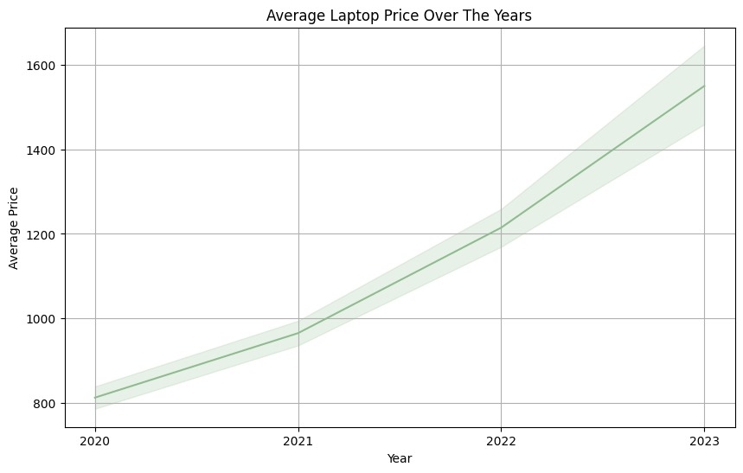

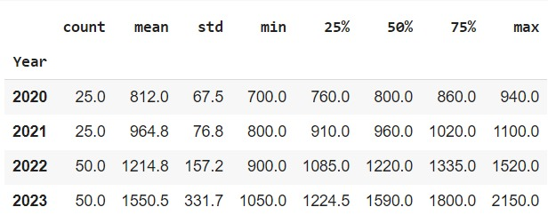

- How does the average price of laptops change over the years from 2020 to 2023?
Line chart is the best option for visualization to observe the change in time. According to given line chart, average price changes can be examined over the years. It is obvious that there is a continuous increasement on average laptop prices and there is an increasement on slopes over the ranges between years from 2020 to 2023. Mean of the laptop prices for 2023 was approximately doubled the mean of the laptop prices for 2020. There is an enhancement on standard deviation rates of laptop prices which also can be observed on differences between maximum and minimum values. This demonstrates that there is an increasing variability among laptop prices over years. The growing standard deviation indicates that the price range expanded annually, maybe as a result of the release of both more expensive and less expensive models, as well as a rise in the variety of laptop features and specifications. To conclude, increasing mean of laptop prices over years might observed as development on technology leads companies to produce more qualified and equipped laptops.

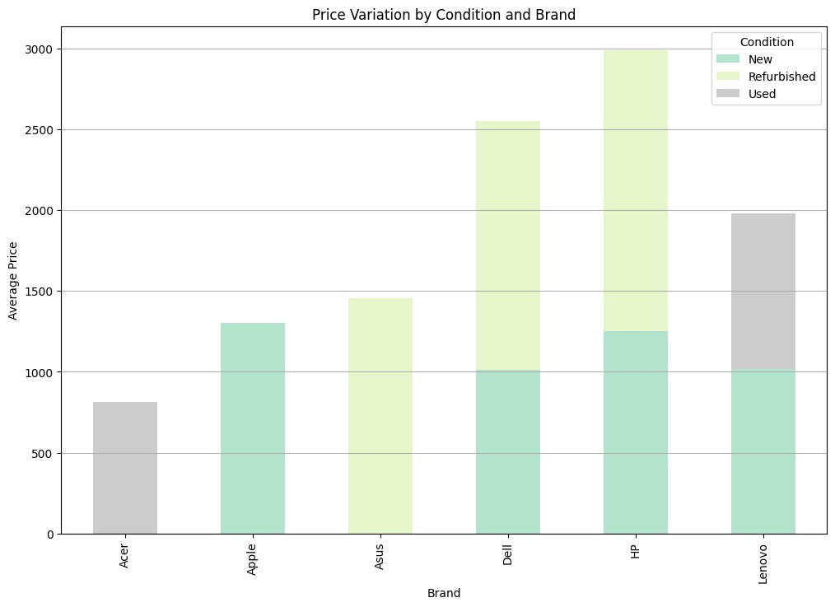

- In which way does condition affect average prices based on brands?
To compare two categorical and one numerical variable, stacked bar chart can be used. In this chart, average prices of laptops were examined if they have affected by condition based on brands.
For Lenovo, it can be observed that average prices of both new produced and second handed laptops are almost equal. Therefore, second handed sales do not cause a major value loss on Lenovo laptops. So that, Lenovo laptops might have long-lasting equipments.
For HP and Dell, average prices of refurbished laptops are higher than new produced laptops. This can be interpreted as that these brands use lower qualified equipment for new laptops while the equipment they use on refurbished laptops has higher quality.
For ASUS, there are no new laptops sold between these years in given dataset.
It can be said that this brand doesn’t produce much laptops or possible complications during production cause this brand to sell refurbished laptops.
For Apple, to examine laptops of this brand, refurbished or used laptops are not sold during these years in our dataset. As a reason, it could be said that users are satisfied from the laptops they use. So that, they are not willing to sell or refurbish their laptops. In addition, new laptops of this brand are more expensive than the new laptops produced by other brands.
For Acer, there are only sales of used laptops between these years in our dataset. Additionally, sales are lower than the other brands for Acer in general. As a reason, this brand could be using less qualified equipments.
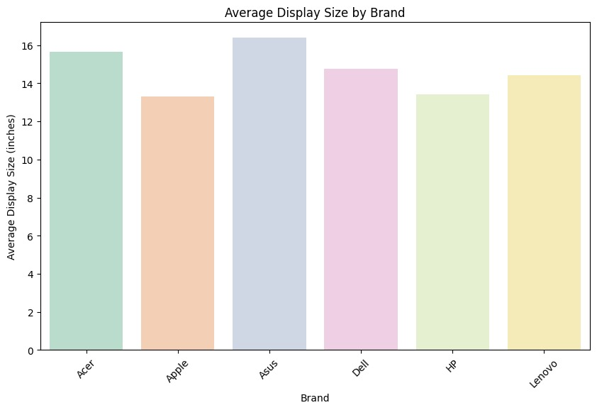
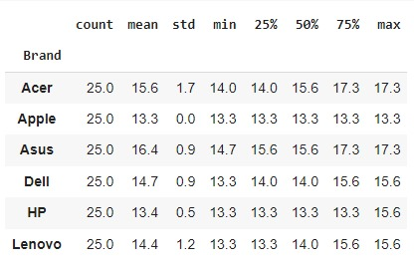

- How does display size vary among brands?
Since there are one numerical and one categorical variable, bar chart is suitable for visualizing. Asus produces the laptops with the largest display size on average, which is 16.4 whereas Apple has the smallest display size on average which is 13.3. It could be inferred that, laptops produced by Apple and HP are more compact, business oriented and portable since they have the lowest display on average size among brands. Against this statement, reason why Asus laptops have largest display sizes on average, could be inferred by these laptops are more game and performance focused. Apple’s average display size has 0 standard deviation change between 2020-2023. This means that Apple didn’t make any change on display sizes of laptops. However, Acer has the biggest standard deviation which means it has the largest variation among display sizes of laptops.
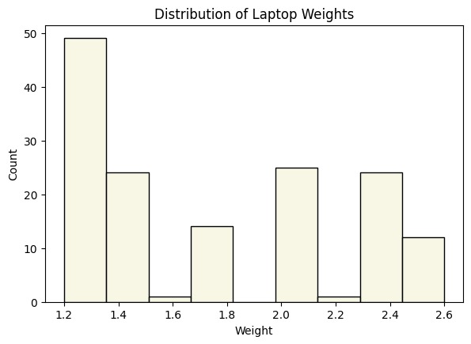

- Which weight of laptops are preferred more by users?
To examine the distribution of weight, it is decided that histogram is the best visualization tool. Firstly, the histogram seemed to be approximately right skewed. Thus, it can be said that there is a relationship such as mean>median>mode. From weight rates, it could be detected that modal class is between values 1.2 and 1.4. So that mode is between this interval. From descriptive statistics of this dataset, it is seen that mode is equal to 1.2. Another observation that made is there are no laptops weighted between values 1.8 and 2. From the histogram, it is seen that laptops weighted 1.6 and 2.2 are the less preferred ones. Light weighted laptops are the most preferred ones because they provide ease of use. It is possible to examine the weight characteristics of the laptops in the dataset, which may be important for customer preferences, especially in terms of portability and usage scenarios.

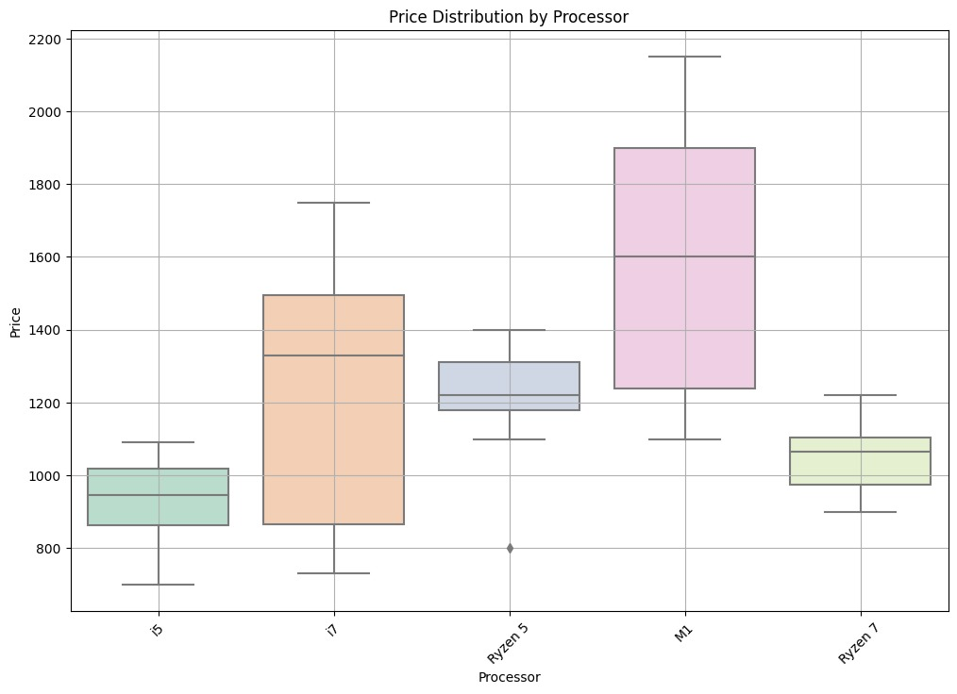

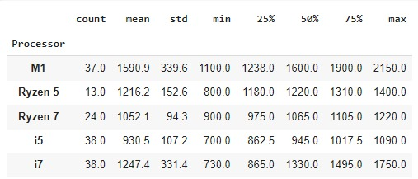

- How processors affect laptop’s costs?
Since price distributions wanted to be examined based on categorical variable processor, boxplot was chosen. Boxplots also displays the spread, median, and presence of outliers for each type of processor. There are boxplots for each of the processors. First, it is seen that processors i7 and m1 have larger distributions also can be seen by descriptive statistics. In addition, Ryzen processors have least variability among other processors. It could be observed that laptops which have M1 processors have the largest prices while laptops which have i5 processors have the lowest prices. While i5 and M1 processors have symmetrical distributions, i7 and Ryzen 7 processors are left skewed and Ryzen 5 processor is right skewed. Ryzen 5 has an outlier value on 800 dollars. Another summary statistics which could be examined by boxplots is median values. In case, M1 has the biggest median value while i5 has the lowest median value. Laptops with i5, Ryzen 5 and Ryzen 7 processors suggesting more consistent pricing across different models.
CONCLUSION

To conclude, examining laptop brands and costs in relation to other hardware components was the main goal of the investigation. It discussed several topics, including how different brands' prices are affected by laptop condition, how typical prices have changed over time, how different brands' displays vary in size, what weight laptops are preferred to have, and how processors affect expenses. Important discoveries consist of:

- From 2020 to 2023, the average cost of laptops will rise steadily but price variation will also increase.
- Prices for laptops are heavily influenced by their condition, with differences being observed based on brands.
- Average display sizes vary between brands; some focus on smaller, more business-oriented models, while others prioritize larger, more performance-oriented versions.
- Preferences for laptop weight, with lighter models being more user-friendly.
- Laptop prices are influenced by the types of processors used, with some processors having a larger price and a different price distribution.

The comprehensive report offers insights into the laptop market to help producers, retailers, and consumers understand market dynamics and make effective choices.

GitHub Link:
https://github.com/yagmurcinar03/Stat112-Final-Project

